Health Education  JCHD has a full time Health Educator offering educational material and presentations on many health topics.  - Group Classes  - Community Health Assessment  - State of the County Health Report  A printed copy of the most current Community Health Assessment or State of the County Health Report can be obtained by calling:  252-448-9111 ext. 3017  Environmental Health  The mission of Environmental Health is to maintain and improve the condition of the community’s environment. For more information, please call:  252-448-1221 ext. 1010  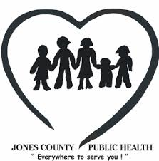 | Contact Us 418 Hwy 58 North, Unit C Trenton, NC 28585 252-448-9111 health@jonescountync.gov Visit us on the web: www.jonescountyhealth.com www.facebook.com/jonescountyhd Company Name Address City, ST ZIP Code  Jones County Health Department  is an Equal Opportunity Provider | Jones County Health Department  Jones County Health Department  - For appointments or questions about our services please call (252)448-9111  - Hours: Monday – Friday: 8:00 am-5:00pm  - 8000  The mission of the Jones County Health Department is to promote sound health policies, prevent and control the spread of disease, and safeguard the integrity of the environment for all citizens of Jones County.  Phone: (252) 448-9111  Hours: Monday - Friday  8:00 am - 5:00 pm
Clinical Services  Clinical services are provided to residents of Jones and surrounding counties. In addition to accepting some insurance plans JCHD also offers services on an income-based, sliding fee scale for uninsured and underinsured clients.  Family Planning  Family Planning Services are confidential and are offered to both men and women. Services include:  Family planning  - Birth control counseling and education  - Reproductive health exams  - Prescription and refills of birth control  - Insertion/removal of birth control devices  Pregnancy testing is also offered and includes referral for prenatal care, Social Services, WIC, and Pregnancy Care Management, if needed. Appointments are preferred but not required.  STD Clinic  JCHD offers confidential STD screening, counseling, treatment and education services daily, as well as diagnostic physical exams when a medical provider is available. For questions about STD services or to schedule an appointment, please call:  252-448-9111 ext. 3013  Naloxone Distribution  The health department offers Narcan nasal spray at no cost. There are 2 units per pack. | Tuberculosis  Tuberculosis (TB) skin testing is available every day of the week EXCEPT Thursday. A nurse can read skin test results any day of the week. JCHD also coordinates diagnostic services and provides treatment for tuberculosis disease.  For more information, please call: 252-448-9111 ext. 3011 Immunizations  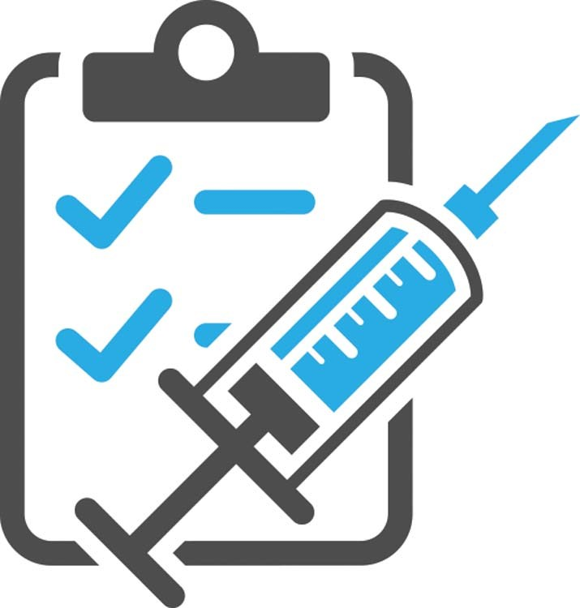  We provide all required childhood immunizations, as well as many adult vaccines. Please call for more information about available vaccines. Immunization services are available daily. Immunizations are provided for:  - Diphtheria, Tetanus, Pertussis (DTaP)  - Polio (IPV)  - Measles, Mumps, Rubella (MMR)  - Chickenpox (Varicella)  - Hepatitis A and B  - Haemophilus Influenzae (Hib)  - Pneumococcal (PCV13)  - Coronavirus (COVID-19)  Child Health  JCHD offers well child check-ups, school health exams and immunizations when a provider is present. Sports physicals and sick child visits are offered when a medical provider is present. Child Health services covers children ages birth through 20 years old  To schedule an appointment, please call:  252-448-9111 ext. 3013 | BCCCP & WISEWOMAN  The Breast and Cervical Cancer Control Program (BCCCP) provides free cancer screening services for eligible women.  For client’s enrolled in BCCCP, we also offer the WISEWOMAN Program (WW), whose mission is to serve women ages 40-64 to improve their overall health and prevent, delay, or control cardiovascular and other chronic diseases.  For more information about BCCCP or WW, please call:  252-448-9111 ext. 3009  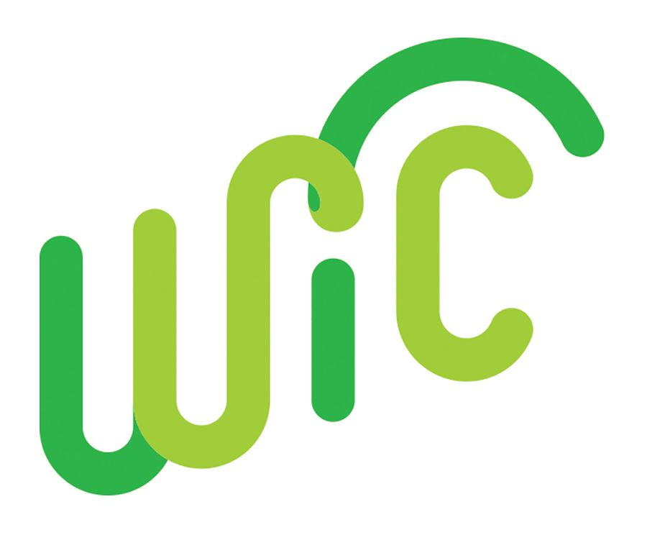  Women, Infants & Children (WIC)  Who is WIC for?  - Infants  - Children up to 5 years of age  - Pregnant women  - Breastfeeding women  What does WIC provide?  - Healthy foods  - Health care referrals  - Breastfeeding support by Certified Lactation Educator and Breastfeeding Peer Counselor  For more information, check out jonescountyhealth.com/?page_id=112 or call:  252-448-9111 ext. 3016  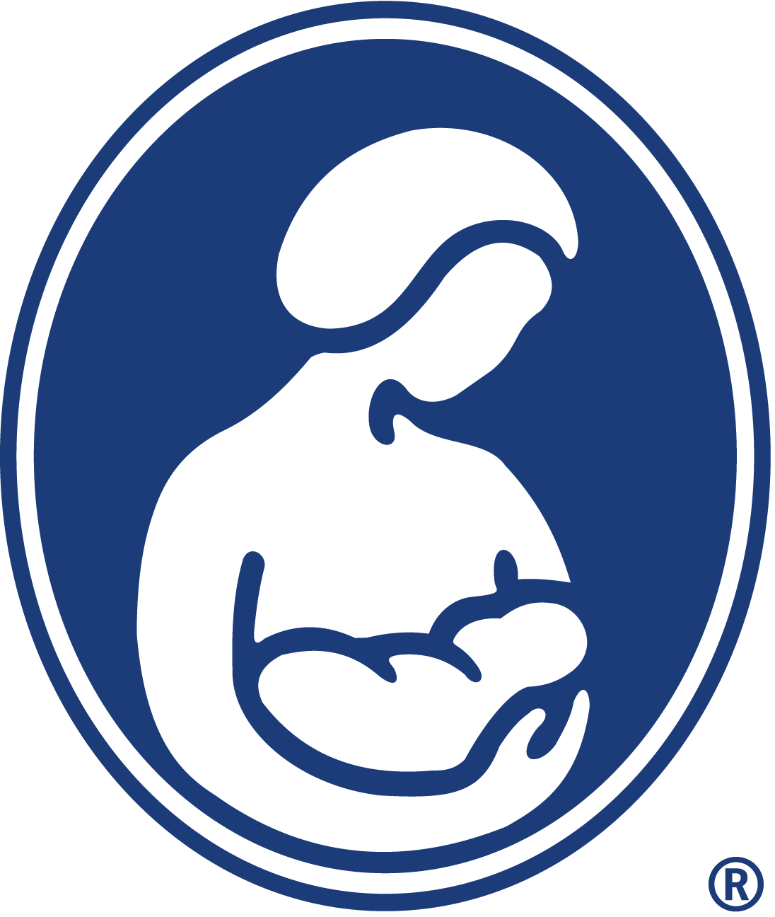We support breastfeeding!  This Photo by Unknown Author is licensed under CC BY-NC-ND

